To add the BME Printers on a Mac you have two options depending your connection.

- Connect by Ethernet, this works well for desktops that are always connected, it is not preferred for laptops as it will not work with wireless.
- Open up the Preferences pane and then Printers and Scanners. You will see something like this: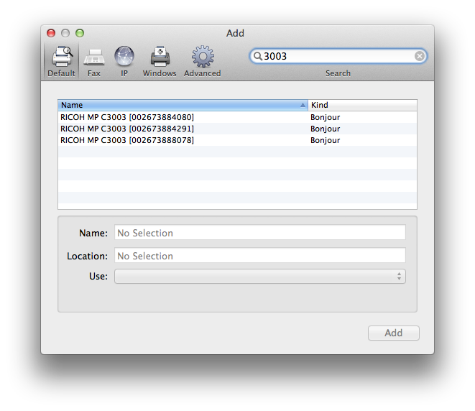
- The printer model is MPC 3003 so you can shorten the list of available printers by typing “3003” in the search window as above if you like.
- Select the printer that corresponds to your floor and/or needs and a driver, if it’s not automatically selected for you.

For a TCP/IP Connection

- Open up the Preferences pane and then Printers and Scanners and then click on “IP”. You will see something like this: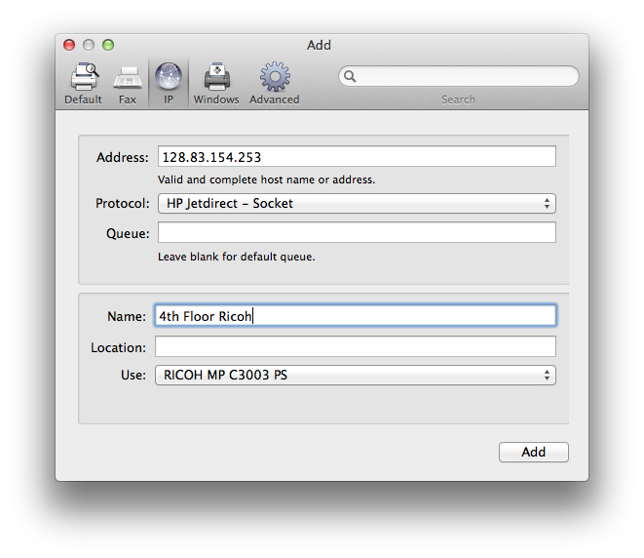
- In the address field type the ip address of the printer you are trying to connect to, leave Queue blank and Protocol: HP Jetdirect – Socket as they are by default.
- In the name field put in the name you want to use for this printer and select a driver.

